Project Title

Hospital Management System

Guided By:

Trainer Name:- Anuj Kumar

Created By:-
Student Name | AFID
Mukesh Kumar | AF04990746

Batch Code : ANP-D2405

Course Code : ITPR

- Introduction
The Hospital Management System is a software application designed to streamline and automate the operations of a hospital. It manages patient records, doctor scheduling, appointments, billing, pharmacy, laboratory information, and administrative tasks. The system reduces manual work, minimizes errors, improves efficiency, and enhances the quality of healthcare services provided to patients.

- Objectives

- To maintain digital patient records securely.
- To facilitate quick and efficient appointment scheduling.
- To streamline doctor and staff management.
- To automate billing and payment workflows.
- To manage pharmacy inventory and lab reports.
- To ensure smooth communication between departments.
- To generate analytical reports for administrative decision-making.

Project Category
Application Development / Application Software

Problem Statement
- Paper forms are difficult to manage
- Difficulty in retrieving patient records.
- Inefficiencies in appointment scheduling and communication.
- Delays in diagnosis, treatment, and billing.
- Increased risk of human errors.
- Lack of integration across departments such as pharmacy, lab, and accounts.

Scope of the Project
This system is intended for:
- Digitize book and member records
- Small, medium, and large hospitals.
- Clinics, diagnostic centers, and multispecialty healthcare institutions.
- Departments such as OPD, IPD, Pharmacy, Billing, Laboratories, and Administration.

Modules of the System
- Patient Management
- Patient registration
- Medical history & records
- Inpatient & outpatient tracking

- Doctor Management
- Doctor registration
- Schedules & availability
- Patient consultations tracking

3. Appointment Management
- Online/offline appointment booking
- Automated reminders
- Queue management
4. Billing & Payments
- Invoice generation
- Payment tracking
- Insurance processing

5. Pharmacy Management
- Medicines inventory
- Issue/return records
- Stock updates and low-stock alerts

6. Laboratory Management
- Test requests
- Report generation
- Integration with patient records

7. Staff/HR Management
- Employee records
- Attendance & shift management

8. Administrative Reports
- Revenue reports
- Patient statistics
- Inventory usage reports

9. Expected Outcomes
- Faster and more accurate hospital workflow.
- Improved patient satisfaction.
- Reduced paperwork and manual errors.
- Centralized and secure data storage.
- Better decision-making through reports and analytics.

10. Conclusion
The Hospital Management System will digitalize hospital operations, improve efficiency, and enhance patient care. It serves as an essential tool for modern healthcare institutions to manage their operations seamlessly and effectively.

✅ 1. Patient Table
Field Name | Data Type | Description
Patient_ID | INT (PK) | Unique patient identifier
Name | VARCHAR(100) | Patient full name
Age | INT | Age of patient
Gender | VARCHAR(10) | Male/Female/Other
Address | VARCHAR(200) | Residential address
Contact_No | VARCHAR(15) | Phone number
Email | VARCHAR(50) | Email address
Medical_History | TEXT | Past medical details
Date_Registered | DATE | Registration date

✅ 2. Doctor Table
Field Name | Data Type | Description
Doctor_ID | INT (PK) | Unique doctor ID
Name | VARCHAR(100) | Doctor full name
Specialization | VARCHAR(50) | Department/Expertise
Qualification | VARCHAR(50) | Degrees (MBBS, MD, etc.)
Contact_No | VARCHAR(15) | Phone number
Email | VARCHAR(50) | Email address
Schedule | VARCHAR(100) | Available timings

✅ 3. Appointment Table
Field Name | Data Type | Description
Appointment_ID | INT (PK) | Unique appointment ID
Patient_ID | INT (FK) | Linked to Patient table
Doctor_ID | INT (FK) | Linked to Doctor table
Appointment_Date | DATE | Date of appointment
Time | TIME | Appointment time
Status | VARCHAR(20) | Booked/Completed/Cancelled

Data Flow Diagram (DFD)

DFD Level 0:

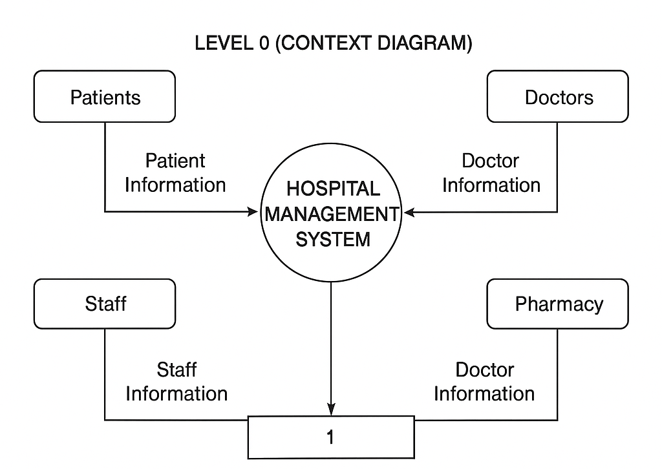

DFD Level 1:

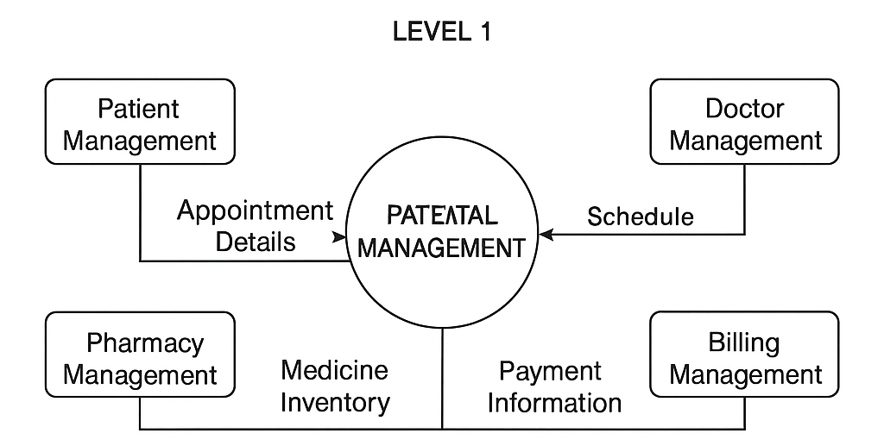

DFD Level 2:

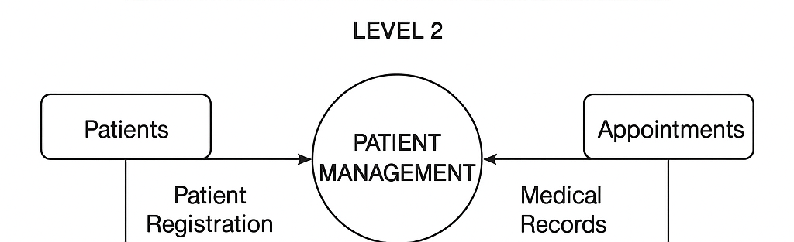

Platform Used

Hardware Requirements
- Intel processor
- 4 GB RAM
- 200 MB free disk space

Software Requirements
- Windows 10/11
- Java JDK (17 or above)
- Eclipse IDE
- MySQL Server & MySQL Workbench
- JDBC Connector JAR

